Screen Clipping

1.

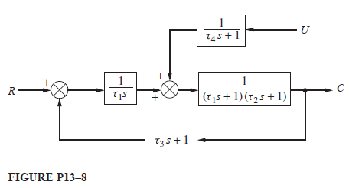

2.

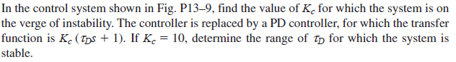

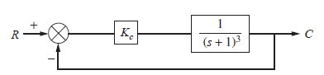

3.

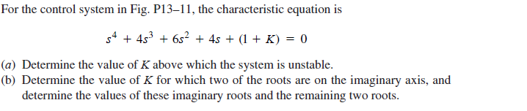

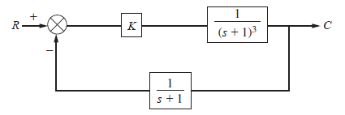

Screen ClippingScreen Clipping

4.

